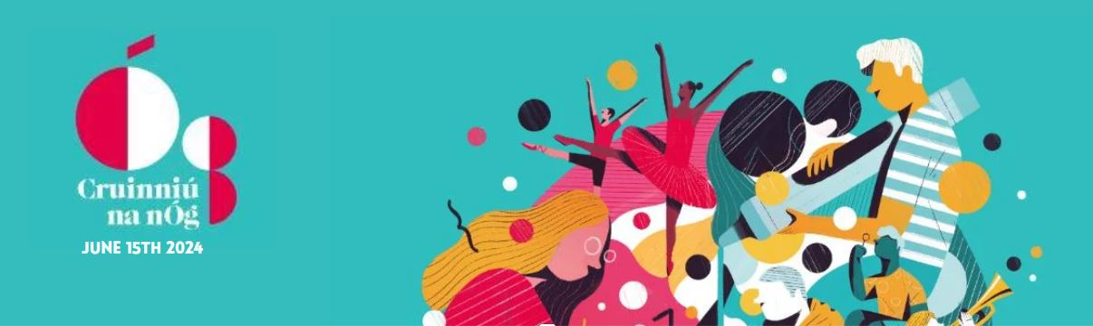
Cruinniú na nÓg 2024
Open Call for Applications from Artists / Arts Organisations / Groups / Individuals for Cruinniú na nÓg County Galway 2024.
Cruinnú na nÓg is a national day of creativity for children and young people happening on Saturday 15th June 2024. It provides opportunities for young people to explore, enhance or celebrate their own creativity.
The closing date for submissions is Friday April 5th at 4pm.
If you have any queries please contact: creativeireland@galwaycoco.ie
Name (Artist / Organisation / Group) :

Contact Name :

Email Address :

Contact Phone Number :

Website or Social Media Pages :

About You - Tell us about your organisation’s work and your experience with children and young people

Your Idea - Tell us what you are doing for Cruinniú na nÓg. Who is delivering the activities? How is it creative, and what impact will it have? (max 500 words)

Target Groups - Who are the activities aimed at? What age groups? Do these activities target young people who have not had these opportunities before?

The Voice of the Child - How does your idea integrate the child’s voice? Does your idea involve active input from children and / or young people?

Timeline - If this is a series of workshops, when will they start and how long will they run?

Language - Does your project incorporate the Irish language? If so then how?

Budget - Please outline your budget below and total financial ask

Artists / Cultural Practitioner Fees:

Technical Fees and Production Costs:

Materials:

Equipment Hire

Administration:

Promotion and Publicity:

Other:

TOTAL:

Child Protection - All applicants organising events and activities that involve children and young people under 18 years of age have legal obligations for the protection and safeguarding of children in accordance with the Children First Act, 2015. All organisations involved in an application must have, and implement, a Child Protection Policy that is consistent with the Act and current guidelines and all staff / volunteers working with children must have appropriate training and be Garda vetted. Please Confirm that your project is compliant with Child Protection legisation:

YES | NO

I confirm that all the above information is accurate to the best of my knowledge

Signed:

Date:

